Model Selection & Architecture Design
Date | 13 July 2026
Team ID
Project Name | Voice-Based Concept Understanding Analyzer (VBCUA)
Model Selection & Architecture Design
This section describes the models selected for the Voice-Based Concept Understanding Analyzer (VBCUA), the reasoning behind their selection, the system architecture, and the associated integration, context-handling, tooling, and scalability considerations.
Model Selection & Architecture Design | Selected model(s):  VBCUA does not use a generative or chat-based large language model such as Gemini Pro/Flash or Vertex AI. It uses two pre-trained, task-specific models: OpenAI Whisper (“base” size) for automatic speech-to-text transcription, and Sentence Transformers (all-MiniLM-L6-v2) for generating text embeddings used in semantic similarity comparison.  Reason for model selection:  Whisper “base” was selected as a lightweight, open-source speech recognition model that runs locally without an external API dependency or associated usage cost, making it suitable for an academic prototype with modest hardware requirements.  all-MiniLM-L6-v2 was selected because it is a compact, fast Sentence Transformer model well-suited to short-to-medium length text (such as a spoken concept explanation), offering a good balance between semantic accuracy and inference speed on CPU-only machines.  System architecture diagram:  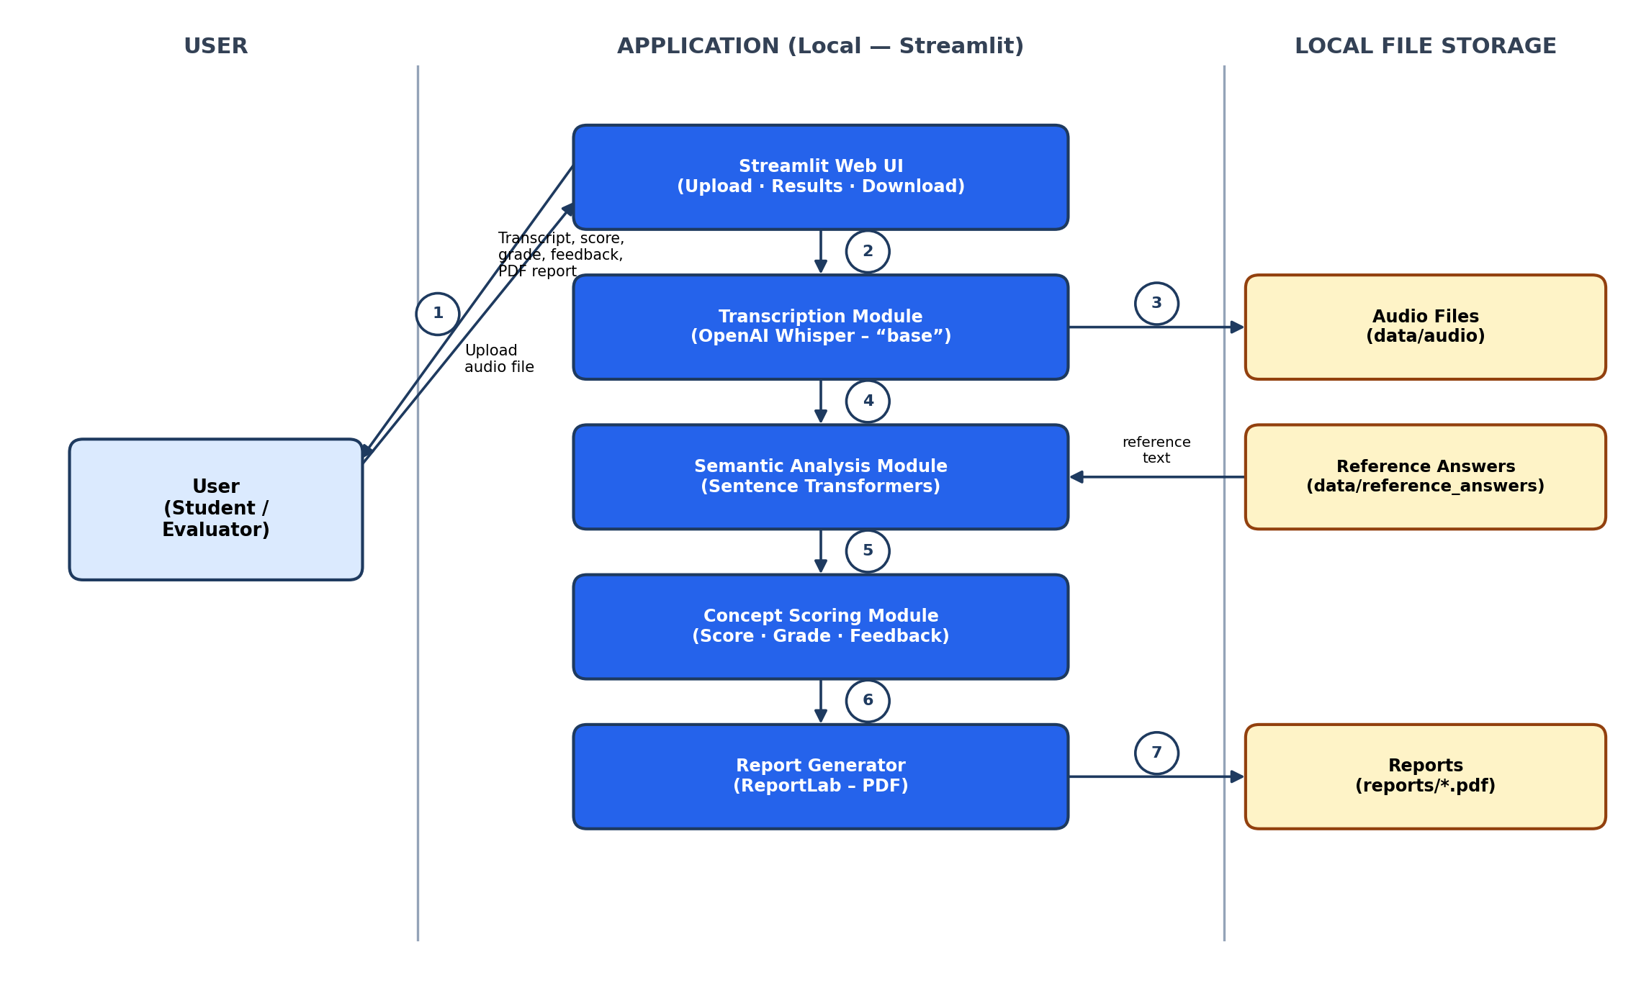  Figure 1: VBCUA System Architecture (Local, Single-Process Deployment)  Workflow design:  VBCUA does not follow a prompt-based generative workflow (User → Prompt → Model → Output), since neither Whisper nor Sentence Transformers is prompted with instructions. The actual workflow is: User → Audio Upload → Transcription (Whisper) → Semantic Comparison against the reference answer (Sentence Transformers) → Scoring & Grading → Output (on-screen results and downloadable PDF report).  API integration architecture:  Both models run locally within the same Python process as the Streamlit application; there is no integration with an external, cloud-hosted model API (such as Gemini or Vertex AI) in the current version. Model classes are loaded directly from the openai-whisper and sentence-transformers Python packages and cached in memory for reuse across a session.  Token / context handling:  Whisper processes raw audio directly and is not subject to a text token limit at the input stage. The Sentence Transformer model (all-MiniLM-L6-v2) has a maximum input sequence length (typically 256 word-pieces); text beyond this length is truncated internally by the model during encoding.  Future enhancement: the current implementation does not explicitly chunk or summarise very long transcripts before similarity scoring. For substantially longer spoken responses, adding explicit chunking or truncation-aware handling is identified as a necessary improvement to avoid silently dropping content beyond the model's context window.  Libraries & tools used:  openai-whisper (speech-to-text), sentence-transformers and torch (semantic embeddings and similarity), streamlit (web interface), reportlab (PDF report generation), and python-dotenv, numpy, and related supporting packages listed in requirements.txt.  Scalability considerations:  The current architecture loads both models once per process and caches them in memory (module-level singleton pattern), which avoids reloading overhead within a session but is designed for single-user, single-session use rather than concurrent multi-user access.  Future enhancement: scaling to multiple concurrent users would require moving model inference behind a dedicated backend service (rather than within the Streamlit process directly), introducing a request queue, and deploying to a cloud environment with sufficient compute — none of which is implemented in the current version.

